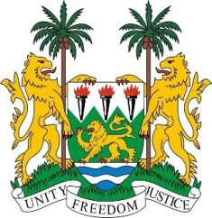
SIERRA LEONE
22nd Session of the UPR

LIBYA

Statement by Ambassador Yvette Stevens

13 May 2015

Mr President,

Sierra Leone welcomes the high-level delegation of the Libya and thanks them for their oral update.

Sierra Leone appreciates the challenges Libya has faced in recent years, especially following the 2014 violence, but believes that more could be done to ensure the safety and protection of its people. In this connection, Sierra Leone commends Libya for establishing its National Council for Civil Liberties and Human Rights and urges Libya to ensure its conformity with the Paris Principles.

In addition, the Constitution Drafting Committee should aim to ensure that the new constitution is fully compliant with human rights standards. Furthermore, Sierra Leone encourages Libya to implement policies to more effectively address the issue of IDPs and to better protect the lives of persons migrating by sea.

Recommendations:

- Ratify the ICPPED and the CRPD.
- Submit all overdue reports to the relevant UN treaty bodies.
- Accede to the 1951 Convention on the Status of Refugees and its 1961 Protocol and put in place mechanisms for determining refugee status
- Draw up plans for transitional justice to ensure that all perpetrators of human rights abuses would be brought to justice.

Sierra Leone wishes Libya a successful completion of this UPR cycle.

Thank you, Mr President.

